Hansen’s Cinema

Website Design

John Hansen

Web Based Apps in IT Final Project

The purpose of this site is to provide the town a local theatre to watch the biggest box office films. There will be 3 screens rotating the most popular movies. The site will contain 5 pages: Home, Tickets, Concession, Rewards, and Contact Us. Users would be able to order tickets and concessions before arriving to the theatre. A rewards system will be in place for customers who wish to sign up with the program to earn free concession and tickets. A form will be utilized on the Contact Us page.

Navigation Flow

Homepage

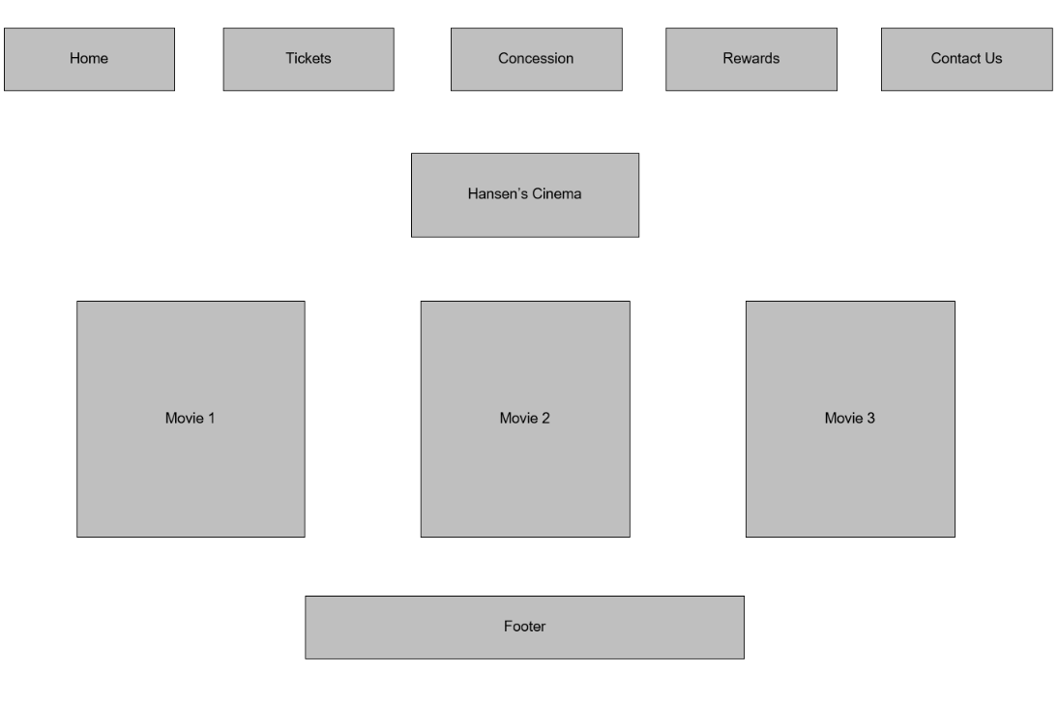

Tickets

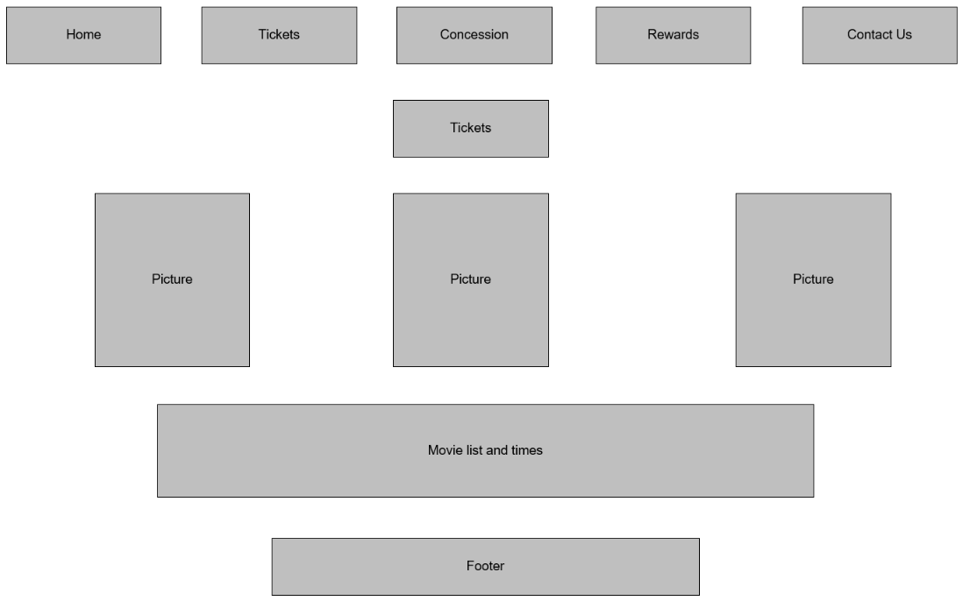

Concession

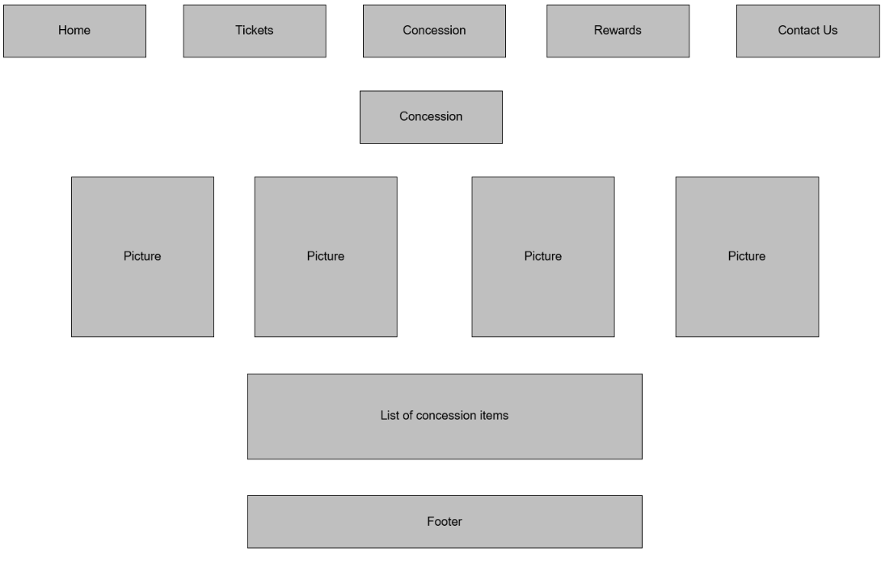

Rewards

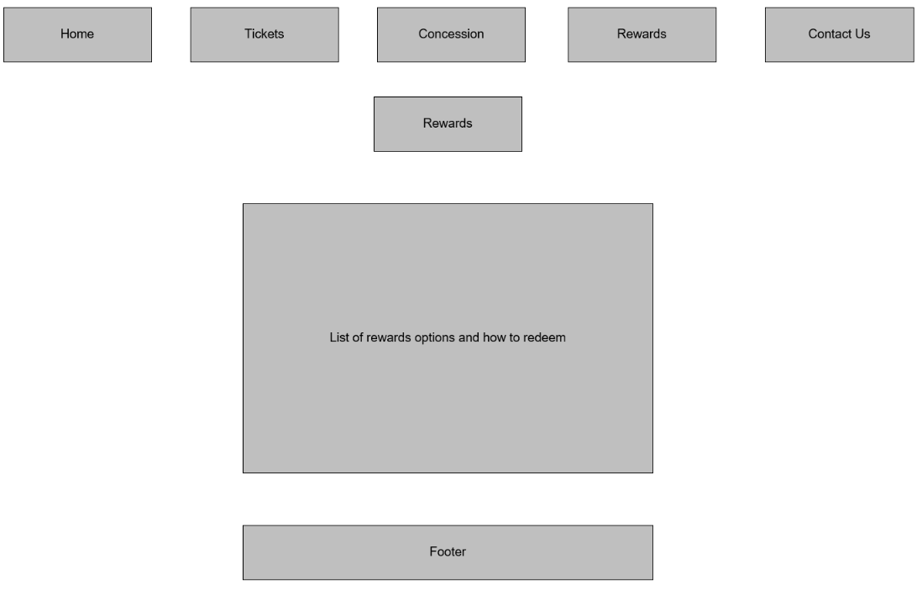

Contact Us

